**Java Memory Management**

Java memory management is the process by which the Java Virtual Machine (JVM) automatically handles the allocation and deallocation of memory. It uses a garbage collector to reclaim memory by removing unused objects.

## JVM Memory Structure

JVM defines various runtime data areas used during the execution of a program. Some of the areas are created by the JVM, whereas some are created by the threads that are used in a program.

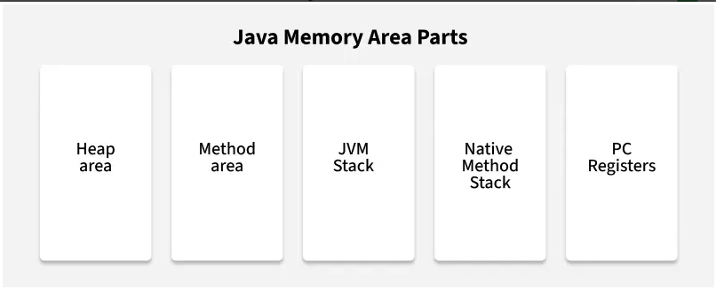

### Heap Area

* Heap is a shared runtime data area where objects and arrays are stored. It is created when the JVM starts.
  1. *Scanner sc = new Scanner(System.in)*

### Method Area

* Method area is a logical part of the heap and it is created when the JVM starts.

### JVM Stacks

* A stack is created when a[thread](https://www.geeksforgeeks.org/java/java-threads/)is created and the JVM stack is used to store method execution data, including local variables, method arguments and return addresses.

### Native Method Stacks

* Native method stack is also known as C stacks.
* This memory is allocated for each thread when it is created and can have either a fixed or dynamic size.

### Program Counter (PC) Registers

* Each JVM thread has a Program Counter (PC) register.
* For non-native methods, it stores the address of the current JVM instruction.